ACCELERATION
Chapter 26
- How did Duncan and Vinny prepare for their night?
- Why do the boys decide to split up?
- What is their plan for keeping in touch?
- What does Duncan learn about Jumbo?
- What does Vinny learn about Red?
Chapter 27
- What crime occurred on the Toronto Subway the night before? Describe the whole crime.
- Why does Vinny call Duncan at the Lost and Found?
- Does Duncan decide to continue with his quest to find Roach? What do you think he should do?
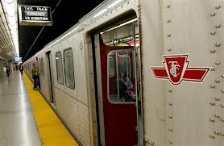

Chapter 28
- Why did Jacob ask to go work in “the Morgue”?
- Describe the man who comes looking for the book.
- What does Duncan decide to do when he sees Roach for the first time?
- Which station does Roach get off the subway at?
- What does he do after he gets off the subway? Describe his trip in full detail.
- Describe number 18 Cedar Road.
- If you were Duncan standing outside of 18 Cedar Road what would your next move be? Explain your reasoning.
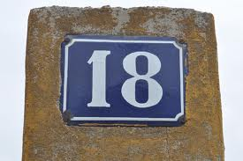
Chapter 29
- Why does Duncan decide to call Wayne?
- What do you think Vinny would say if he knew what Duncan was up to?
- Do you think that it is a good idea for Duncan to try to get into Roach’s house? Why or Why not?
- a) What would you do if you were in Duncan’s position? b) What is the right thing to do?
